[E122] Boil heater element

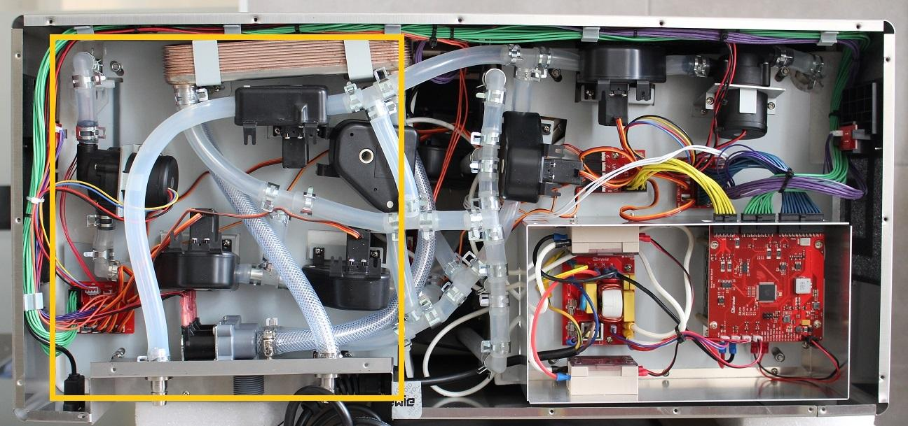

The boil heater element is located under the boil side service plate. To reach the heater element it is necessary to partially remove the whole plate.

Move aside the USB port and the rear plate by unscrewing the indicated screws.

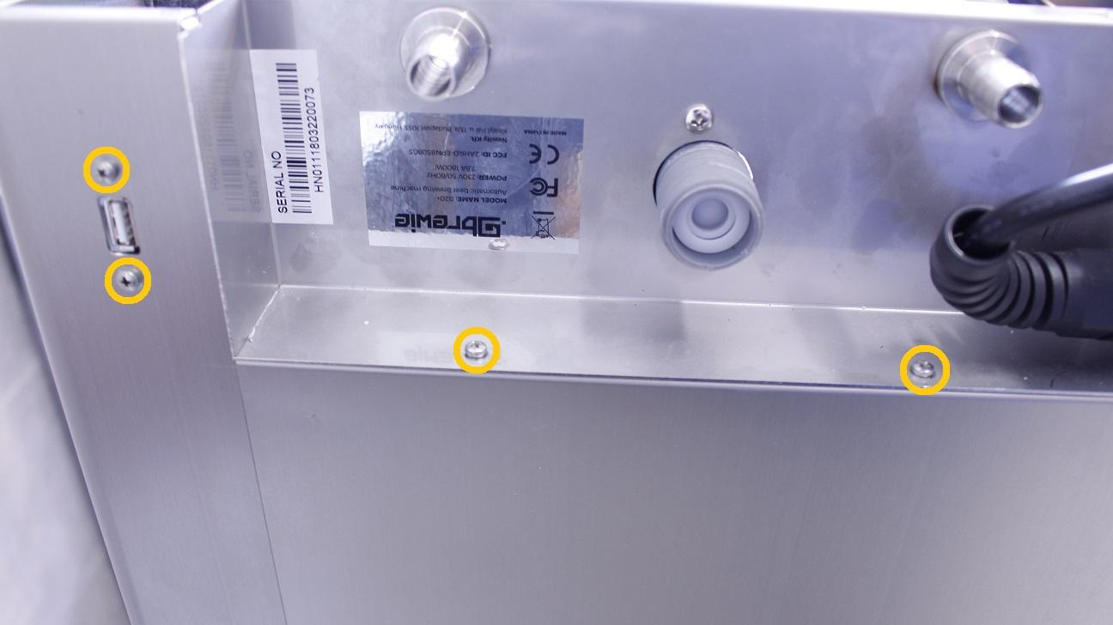

Unscrew two of the boil plate fastening locknuts.

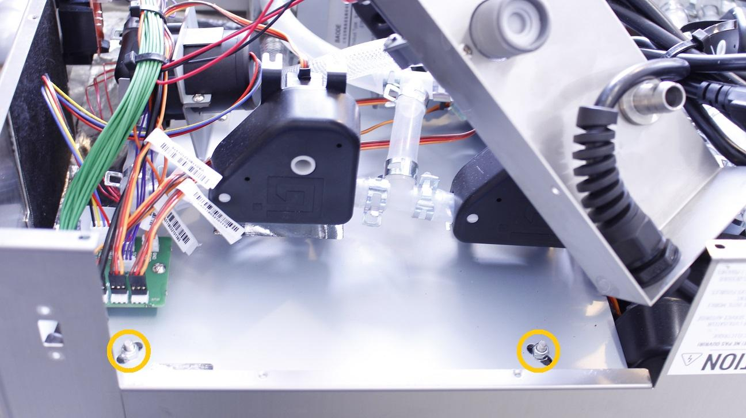

Disconnect the cable from the power button PCB.

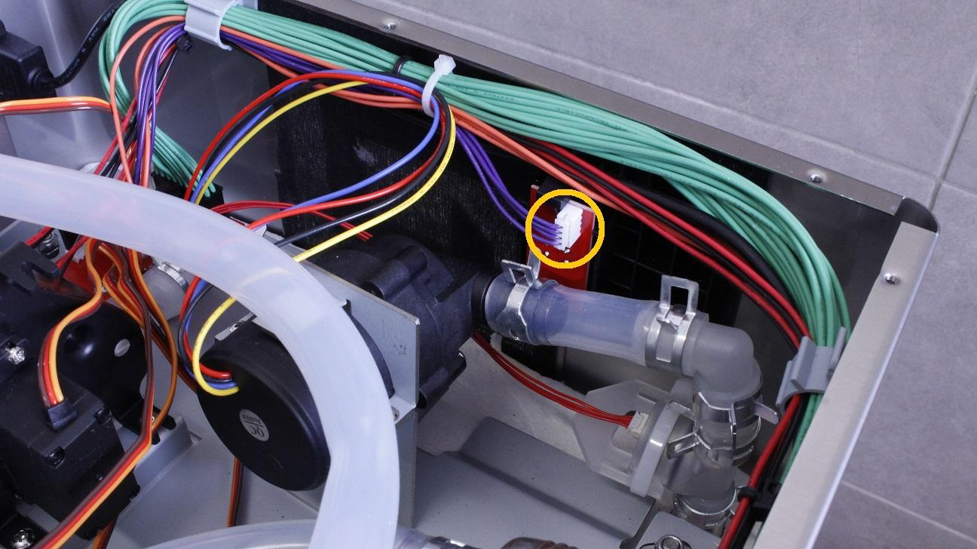

Remove the cable bundle from all of the holders.

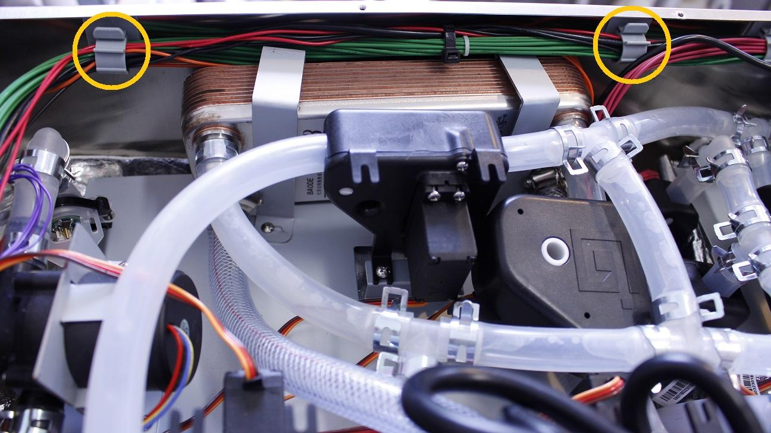

Disconnect the silicone tube from the outlet of the boil tank by pulling off the clamp right under the pressure meter.

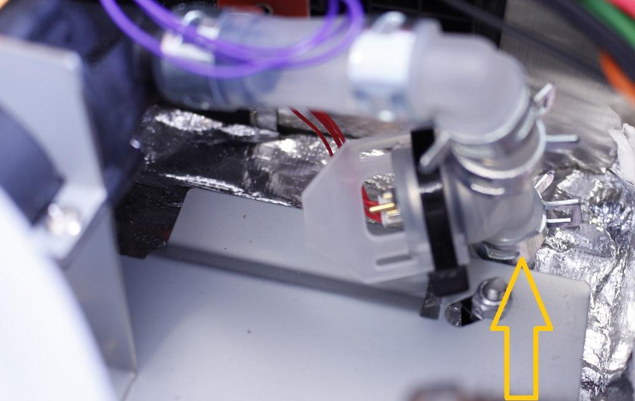

First the clamps of the heat exchanger have to be removed then the remaining two boil plate fastening locknuts.

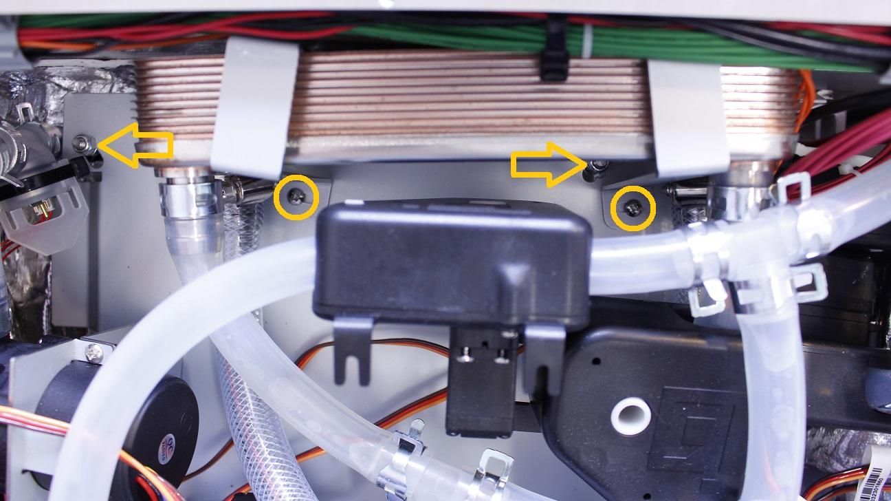

Open up the whole plate.

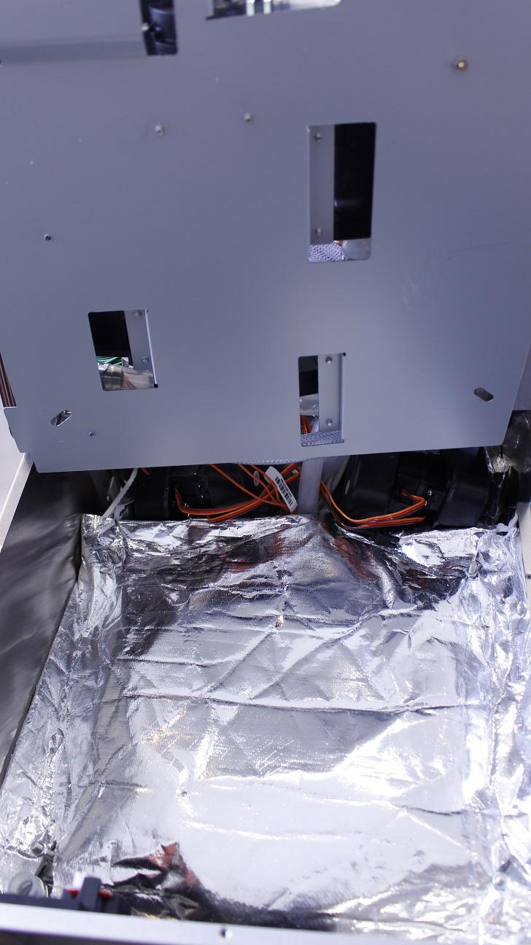

Carefully pull off the heat insulation from the threads and the outlet pipe.

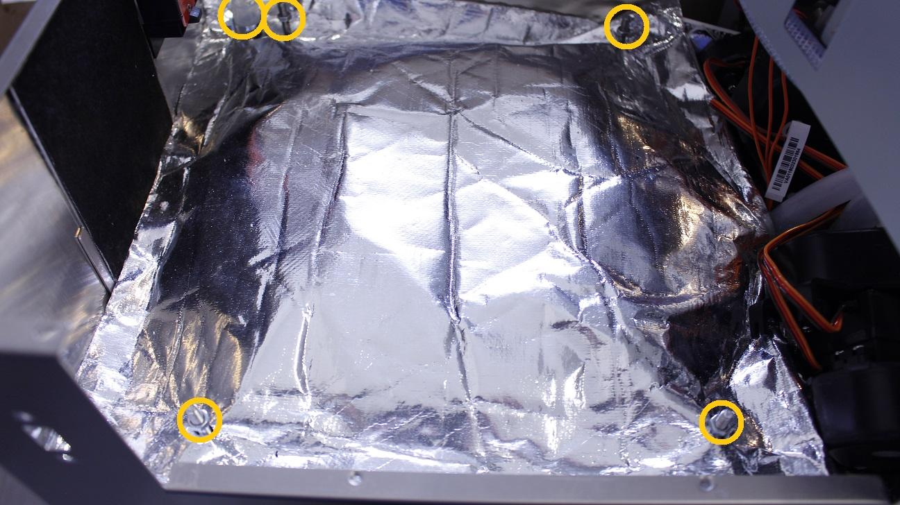

Simply turn the fastening clamps aside from the heater element and remove the isolation rubber.

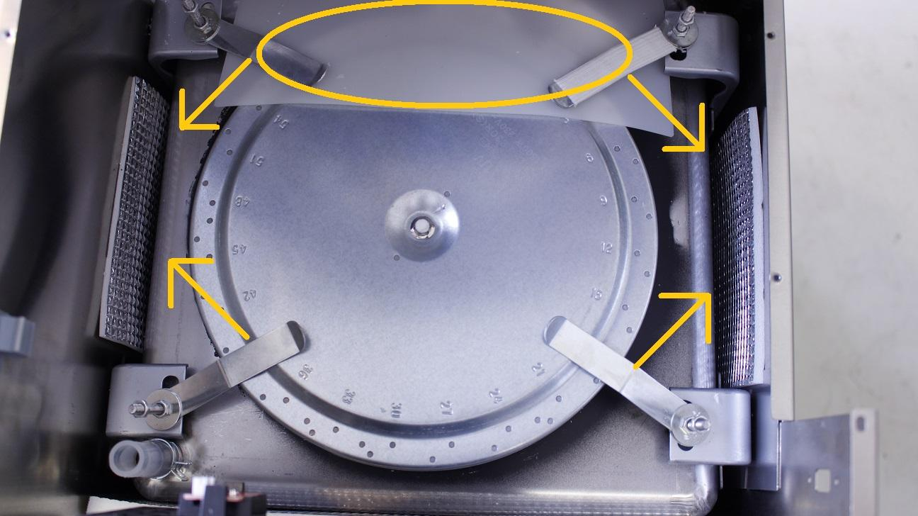

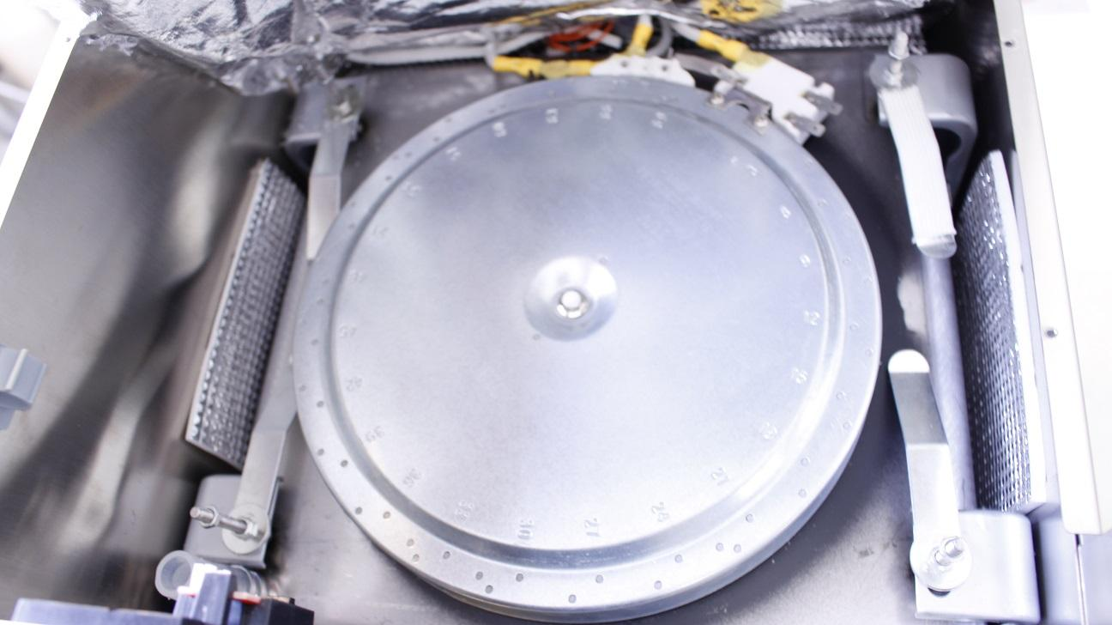

Cut the solidified adhesive to pull off the cables from the pins of the heater.

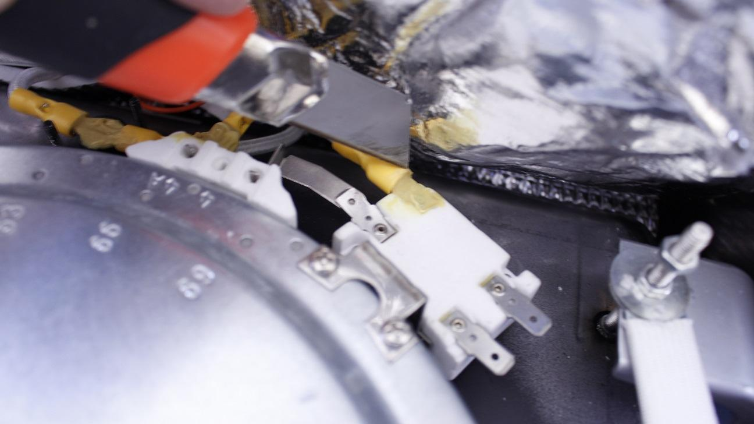

Reassemble consists of the same steps in reverse.

IMPORTANT! Don’t scratch the black heat absorbing paint under the element as any damage decreases the efficiency.